|  |
| --- |
|  |
| E-Commerce Design Document |
| A E-Commerce Case Study Project |
|  |
| **Paul Laudun** |
| **10/4/2017** |

The contents within this document is my case study project for an E-Commerce website design. The purpose of this document is to give a Word Document version of a Design Specification document for an imaginary E-Commerce solution. This design document lacks some parts, but it largely covers all the main parts of an E-Commerce site and how I would design it. This case study started off an idea to redesign a website for my prior employer’s E-Commerce solution. Some of my other influences were; Amazon’s website, Autozone’s website, and Barnes & Noble website. This, website was designed strictly in Axure 8. If you like, or if you would like to offer possible employment, please feel free to contact me. The site is meant to portray a clear, simple, design. With enough information to not overwhelm the user, but also provide enough information. This is to give an intuitive design that gives the feeling of control and the ability to easily, and effortlessly, navigate throughout the entire website. All this while also having a design that could be modular and modified to change and fit client’s needs.

Table of Contents

1. Pages 4

1.1. Page Tree 4

1.2. Home 5

1.2.1. User Interface 5

1.2.2. Widget Table 6

1.3. ProductPageExample 7

1.3.1. User Interface 7

1.3.2. Widget Table 8

1.4. DepartmentPageExample 9

1.4.1. User Interface 9

1.4.2. Widget Table 10

1.5. SubDepartmentPageExample 11

1.5.1. User Interface 11

1.5.2. Widget Table 12

1.6. CartPageExample 14

1.6.1. User Interface 14

1.6.2. Widget Table 15

1.7. CartCheckoutPageExample 16

1.7.1. User Interface 16

1.7.2. Widget Table 17

1.8. CartCheckoutFinishPageExample 18

1.8.1. User Interface 18

1.8.2. Widget Table 19

1.9. MyAccountPageExample 20

1.9.1. User Interface 20

1.9.2. Widget Table 21

1.10. AddNewCreditCard 22

1.10.1. User Interface 22

1.10.2. Widget Table 23

1.11. NewCreditCardSaved 24

1.11.1. User Interface 24

1.11.2. Widget Table 25

1.12. SelectNewGiftCard 26

1.12.1. User Interface 26

1.12.2. Widget Table 27

1.13. AddNewGiftCard 28

1.13.1. User Interface 28

1.13.2. Widget Table 29

1.14. AddNewAddress 30

1.14.1. User Interface 30

1.14.2. Widget Table 31

1. Pages
   1. Page Tree

Home  
 ProductPageExample  
 DepartmentPageExample  
 SubDepartmentPageExample  
 CartPageExample  
 CartCheckoutPageExample  
 CartCheckoutFinishPageExample  
 MyAccountPageExample  
 AddNewCreditCard  
 NewCreditCardSaved  
 SelectNewGiftCard  
 AddNewGiftCard  
 AddNewAddress

* 1. Home
     1. User Interface

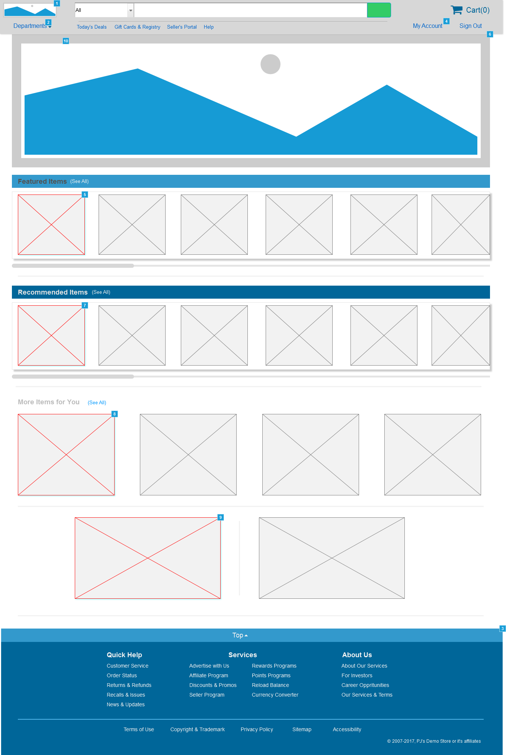

* + 2. Widget Table

|  |  |  |
| --- | --- | --- |
| Footnote | Name | Interactions |
| 1 | LogoImg | OnClick:  Case 1:  Open Home in Current Window |
| 2 | link_pop_Departments | OnClick:  Case 1:  Toggle pop_Toys, pop_Health&Beauty, pop_Home&Garden, pop_Computers, pop_Games, pop_Music, pop_Movies, pop_Books, pop_Clothing, pop_Appliances, pop_Electronics, Dept_PopOutPanel_Main |
| 3 | ToTop_Link_Hotspot | OnClick:  Case 1:  Scroll to TopPanel (y only) ease in cubic 500ms |
| 4 | link_MyAccount | OnClick:  Case 1:  Toggle Account_PopOutPanel_Main, link_Watchlists, link_LinkProducts, link_RegisterSeller, link_PointsAwards, link_Wallet, link_Addresses, link_PaymentMethods, link_Memberships, link_Subscriptions, link_Recommendations, link_Lists, link_Orders, link_Account |
| 5 | img_link_Feat_Item1 | OnClick:  Case 1:  Open ProductPageExample in Current Window |
| 6 | MainPageSlideShow | OnClick:  Case 1:  Open ProductPageExample in Current Window |
| 7 | img_link_Rec_Item1 | OnClick:  Case 1:  Open ProductPageExample in Current Window |
| 8 | link_MoreItems_Med1 | OnClick:  Case 1:  Open ProductPageExample in Current Window |
| 9 | link_MoreItems_Large1 | OnClick:  Case 1:  Open ProductPageExample in Current Window |
| 10 | pop_Electronics | OnClick:  Case 1:  Open DepartmentPageExample in Current Window |

* 1. ProductPageExample
     1. User Interface

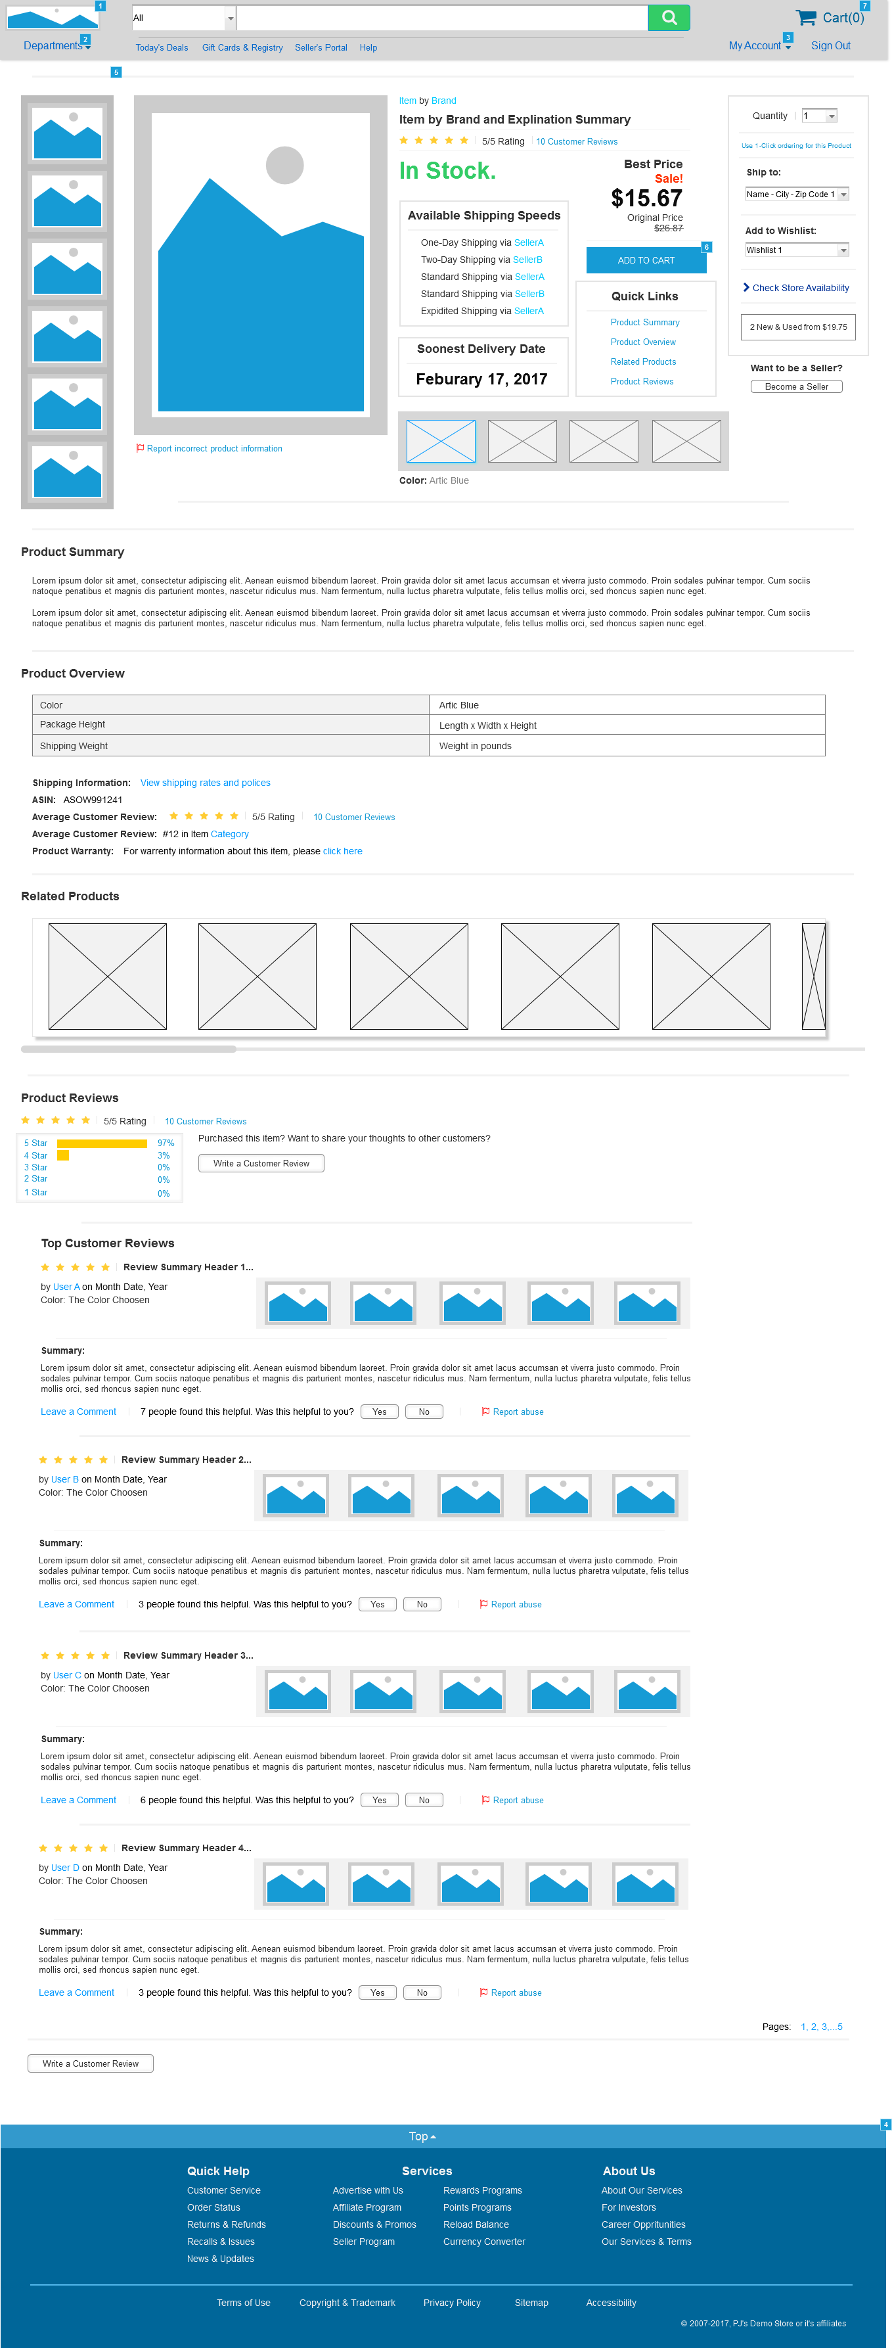

* + 1. Widget Table

|  |  |  |
| --- | --- | --- |
| Footnote | Name | Interactions |
| 1 | LogoImg | OnClick:  Case 1:  Open Home in Current Window |
| 2 | link_pop_Departments | OnClick:  Case 1:  Toggle pop_Toys, pop_Health&Beauty, pop_Home&Garden, pop_Computers, pop_Games, pop_Music, pop_Movies, pop_Books, pop_Clothing, pop_Appliances, pop_Electronics, Dept_PopOutPanel_Main |
| 3 | link_MyAccount | OnClick:  Case 1:  Toggle Account_PopOutPanel_Main, link_Watchlists, link_LinkProducts, link_RegisterSeller, link_PointsAwards, link_Wallet, link_Addresses, link_PaymentMethods, link_Memberships, link_Subscriptions, link_Recommendations, link_Lists, link_Orders, link_Account |
| 4 | ToTop_Link_Hotspot | OnClick:  Case 1:  Scroll to Widget |
| 5 | pop_Electronics | OnClick:  Case 1:  Open DepartmentPageExample in Current Window |
| 6 |  | OnClick:  Case 1:  Open CartPageExample in Current Window |
| 7 | CartLink | OnClick:  Case 1:  Open CartPageExample in Current Window |

* 1. DepartmentPageExample
     1. User Interface

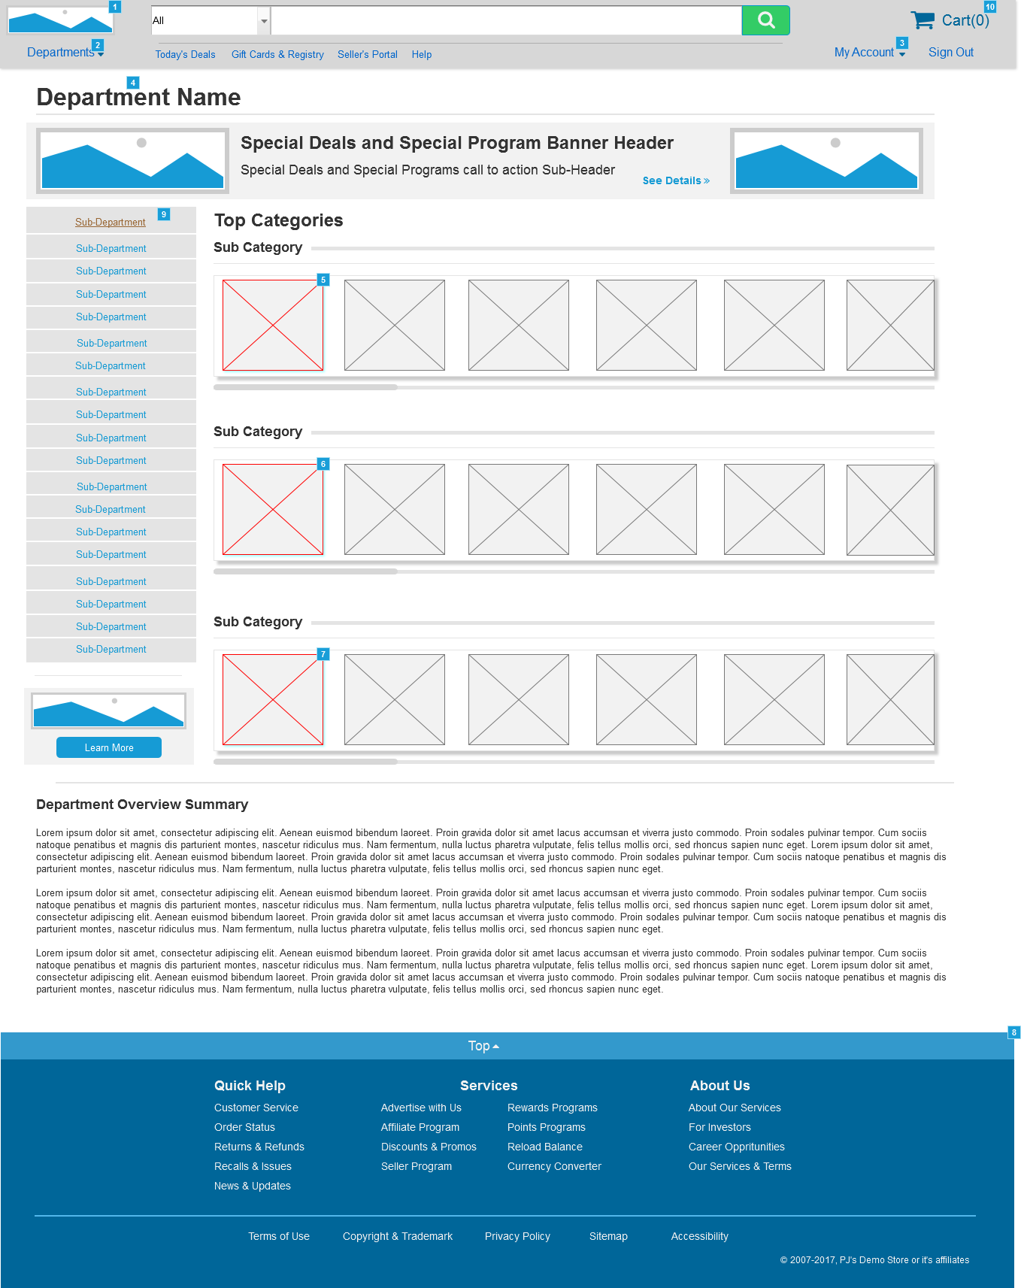

* + 1. Widget Table

|  |  |  |
| --- | --- | --- |
| Footnote | Name | Interactions |
| 1 | LogoImg | OnClick:  Case 1:  Open Home in Current Window |
| 2 | link_pop_Departments | OnClick:  Case 1:  Toggle pop_Toys, pop_Health&Beauty, pop_Home&Garden, pop_Computers, pop_Games, pop_Music, pop_Movies, pop_Books, pop_Clothing, pop_Appliances, pop_Electronics, Dept_PopOutPanel_Main |
| 3 | link_MyAccount | OnClick:  Case 1:  Toggle Account_PopOutPanel_Main, link_Watchlists, link_LinkProducts, link_RegisterSeller, link_PointsAwards, link_Wallet, link_Addresses, link_PaymentMethods, link_Memberships, link_Subscriptions, link_Recommendations, link_Lists, link_Orders, link_Account |
| 4 | pop_Electronics | OnClick:  Case 1:  Open DepartmentPageExample in Current Window |
| 5 | img_link_Feat_Item1 | OnClick:  Case 1:  Open ProductPageExample in Current Window |
| 6 | img_link_Feat_Item1 | OnClick:  Case 1:  Open ProductPageExample in Current Window |
| 7 | img_link_Feat_Item1 | OnClick:  Case 1:  Open ProductPageExample in Current Window |
| 8 | ToTop_Link_Hotspot | OnClick:  Case 1:  Scroll to Widget |
| 9 |  | OnClick:  Case 1:  Open SubDepartmentPageExample in Current Window |
| 10 | CartLink | OnClick:  Case 1:  Open CartPageExample in Current Window |

* 1. SubDepartmentPageExample
     1. User Interface

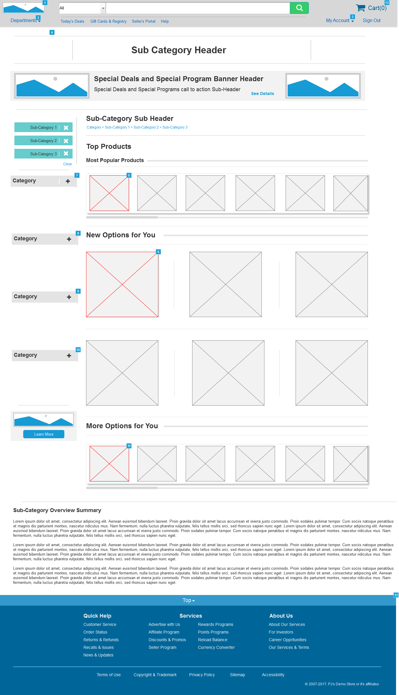

* + 1. Widget Table

|  |  |  |
| --- | --- | --- |
| Footnote | Name | Interactions |
| 1 | LogoImg | OnClick:  Case 1:  Open Home in Current Window |
| 2 | link_pop_Departments | OnClick:  Case 1:  Toggle pop_Toys, pop_Health&Beauty, pop_Home&Garden, pop_Computers, pop_Games, pop_Music, pop_Movies, pop_Books, pop_Clothing, pop_Appliances, pop_Electronics, Dept_PopOutPanel_Main |
| 3 | link_MyAccount | OnClick:  Case 1:  Toggle Account_PopOutPanel_Main, link_Watchlists, link_LinkProducts, link_RegisterSeller, link_PointsAwards, link_Wallet, link_Addresses, link_PaymentMethods, link_Memberships, link_Subscriptions, link_Recommendations, link_Lists, link_Orders, link_Account |
| 4 | pop_Electronics | OnClick:  Case 1:  Open DepartmentPageExample in Current Window |
| 5 | img_link_Feat_Item1 | OnClick:  Case 1:  Open ProductPageExample in Current Window |
| 6 | img_link_Feat_Item1 | OnClick:  Case 1:  Open ProductPageExample in Current Window |
| 7 | cat_Link_HS | OnClick:  Case 1:  Toggle cat_Link_SubCat, cat_Link_Panel, cat_Link_SubCat, cat_Link_SubCat, cat_Link_SubCat |
| 8 | cat_Link_HS | OnClick:  Case 1:  Toggle cat_Link_SubCat, cat_Link_Panel, cat_Link_SubCat, cat_Link_SubCat, cat_Link_SubCat |
| 9 | cat_Link_HS | OnClick:  Case 1:  Toggle cat_Link_SubCat, cat_Link_Panel, cat_Link_SubCat, cat_Link_SubCat, cat_Link_SubCat |
| 10 | cat_Link_HS | OnClick:  Case 1:  Toggle cat_Link_SubCat, cat_Link_Panel, cat_Link_SubCat, cat_Link_SubCat, cat_Link_SubCat |
| 11 | img_link_Feat_Item1 | OnClick:  Case 1:  Open ProductPageExample in Current Window |
| 12 | ToTop_Link_Hotspot | OnClick:  Case 1:  Scroll to Widget |
| 13 | CartLink | OnClick:  Case 1:  Open CartPageExample in Current Window |

* 1. CartPageExample
     1. User Interface

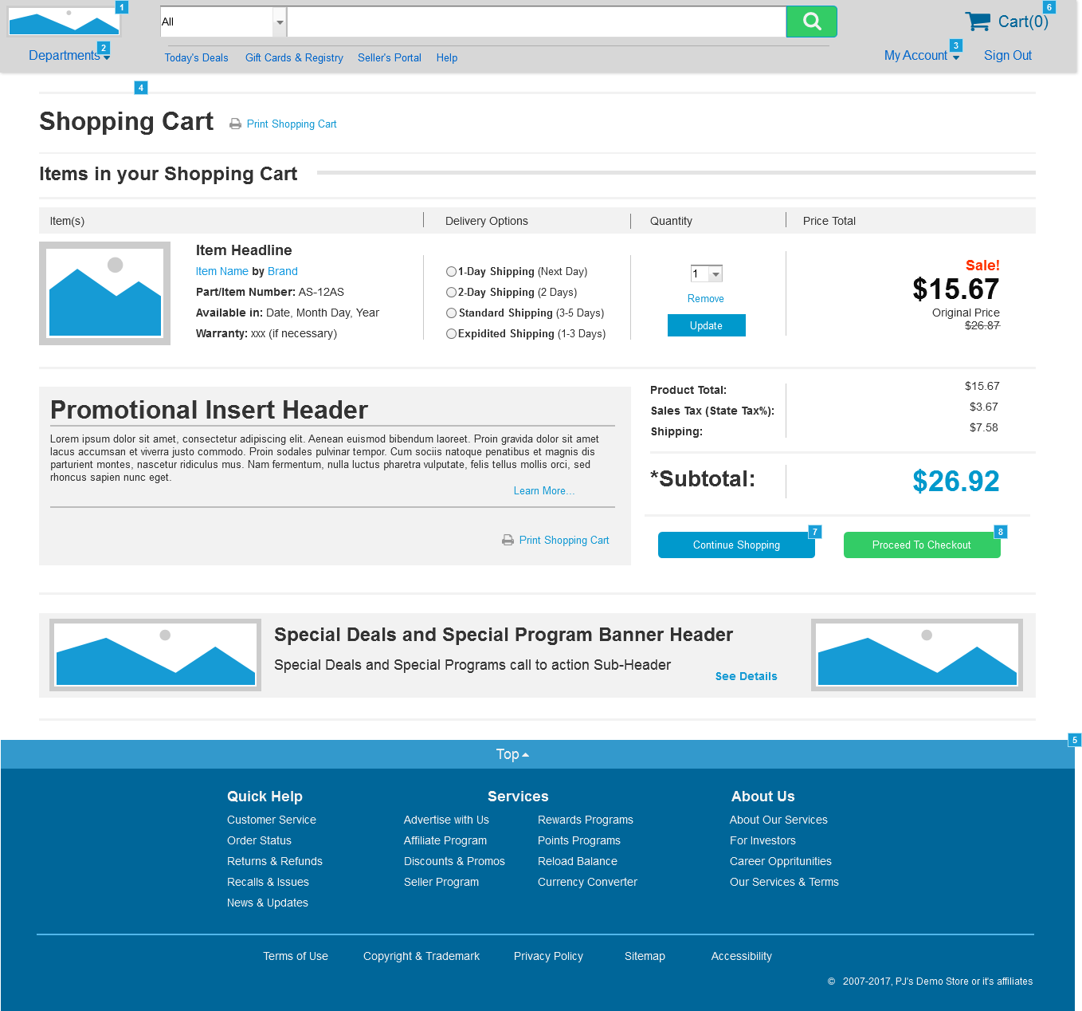

* + 1. Widget Table

|  |  |  |
| --- | --- | --- |
| Footnote | Name | Interactions |
| 1 | LogoImg | OnClick:  Case 1:  Open Home in Current Window |
| 2 | link_pop_Departments | OnClick:  Case 1:  Toggle pop_Toys, pop_Health&Beauty, pop_Home&Garden, pop_Computers, pop_Games, pop_Music, pop_Movies, pop_Books, pop_Clothing, pop_Appliances, pop_Electronics, Dept_PopOutPanel_Main |
| 3 | link_MyAccount | OnClick:  Case 1:  Toggle Account_PopOutPanel_Main, link_Watchlists, link_LinkProducts, link_RegisterSeller, link_PointsAwards, link_Wallet, link_Addresses, link_PaymentMethods, link_Memberships, link_Subscriptions, link_Recommendations, link_Lists, link_Orders, link_Account |
| 4 | pop_Electronics | OnClick:  Case 1:  Open DepartmentPageExample in Current Window |
| 5 | ToTop_Link_Hotspot | OnClick:  Case 1:  Scroll to Widget |
| 6 | CartLink | OnClick:  Case 1:  Open CartPageExample in Current Window |
| 7 |  | OnClick:  Case 1:  Open Home in Current Window |
| 8 |  | OnClick:  Case 1:  Open CartCheckoutPageExample in Current Window |

* 1. CartCheckoutPageExample
     1. User Interface

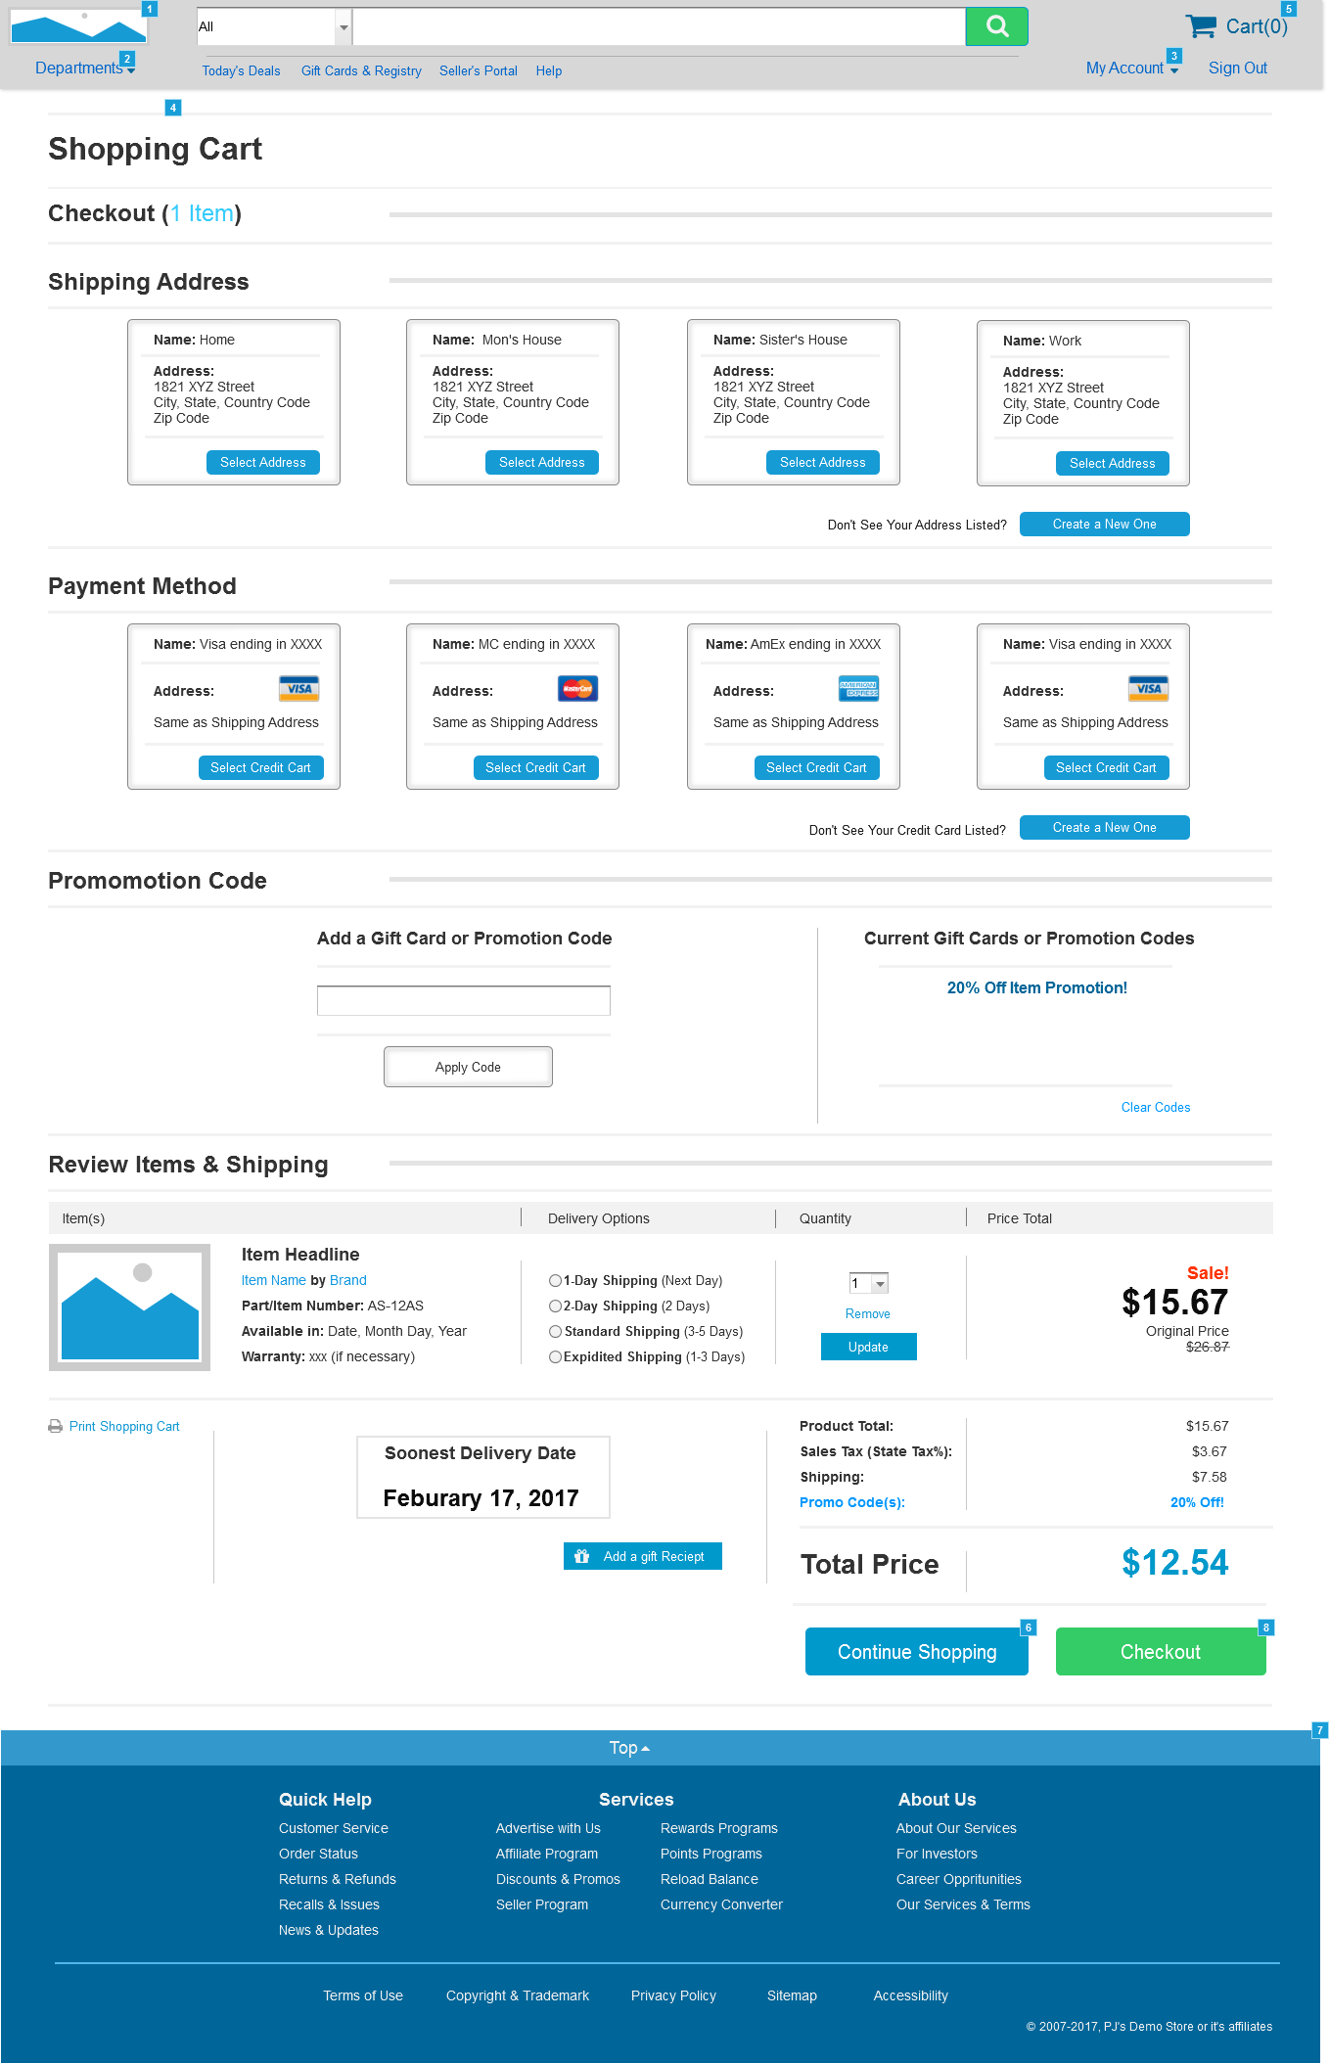

* + 1. Widget Table

|  |  |  |
| --- | --- | --- |
| Footnote | Name | Interactions |
| 1 | LogoImg | OnClick:  Case 1:  Open Home in Current Window |
| 2 | link_pop_Departments | OnClick:  Case 1:  Toggle pop_Toys, pop_Health&Beauty, pop_Home&Garden, pop_Computers, pop_Games, pop_Music, pop_Movies, pop_Books, pop_Clothing, pop_Appliances, pop_Electronics, Dept_PopOutPanel_Main |
| 3 | link_MyAccount | OnClick:  Case 1:  Toggle Account_PopOutPanel_Main, link_Watchlists, link_LinkProducts, link_RegisterSeller, link_PointsAwards, link_Wallet, link_Addresses, link_PaymentMethods, link_Memberships, link_Subscriptions, link_Recommendations, link_Lists, link_Orders, link_Account |
| 4 | pop_Electronics | OnClick:  Case 1:  Open DepartmentPageExample in Current Window |
| 5 | CartLink | OnClick:  Case 1:  Open CartPageExample in Current Window |
| 6 |  | OnClick:  Case 1:  Open Home in Current Window |
| 7 | ToTop_Link_Hotspot | OnClick:  Case 1:  Scroll to Widget |
| 8 |  | OnClick:  Case 1:  Open CartCheckoutFinishPageExample in Current Window |

* 1. CartCheckoutFinishPageExample
     1. User Interface

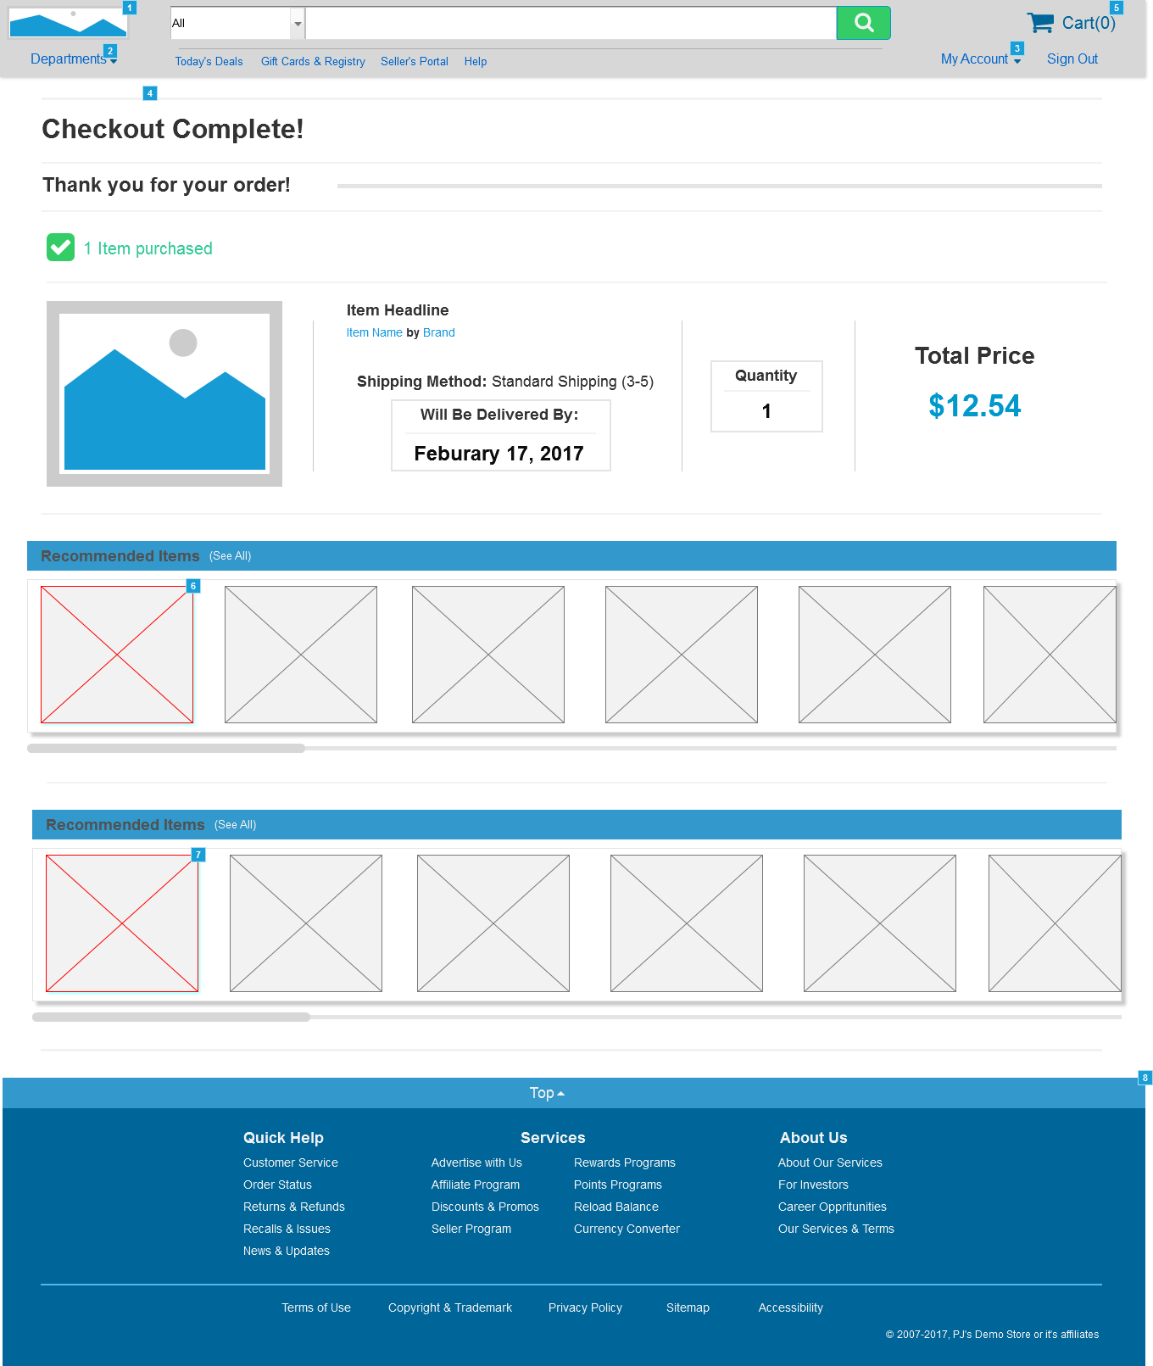

* + 1. Widget Table

|  |  |  |
| --- | --- | --- |
| Footnote | Name | Interactions |
| 1 | LogoImg | OnClick:  Case 1:  Open Home in Current Window |
| 2 | link_pop_Departments | OnClick:  Case 1:  Toggle pop_Toys, pop_Health&Beauty, pop_Home&Garden, pop_Computers, pop_Games, pop_Music, pop_Movies, pop_Books, pop_Clothing, pop_Appliances, pop_Electronics, Dept_PopOutPanel_Main |
| 3 | link_MyAccount | OnClick:  Case 1:  Toggle Account_PopOutPanel_Main, link_Watchlists, link_LinkProducts, link_RegisterSeller, link_PointsAwards, link_Wallet, link_Addresses, link_PaymentMethods, link_Memberships, link_Subscriptions, link_Recommendations, link_Lists, link_Orders, link_Account |
| 4 | pop_Electronics | OnClick:  Case 1:  Open DepartmentPageExample in Current Window |
| 5 | CartLink | OnClick:  Case 1:  Open CartPageExample in Current Window |
| 6 | img_link_Rec_Item1 | OnClick:  Case 1:  Open ProductPageExample in Current Window |
| 7 | img_link_Rec_Item1 | OnClick:  Case 1:  Open ProductPageExample in Current Window |
| 8 | ToTop_Link_Hotspot | OnClick:  Case 1:  Scroll to Widget |

* 1. MyAccountPageExample
     1. User Interface

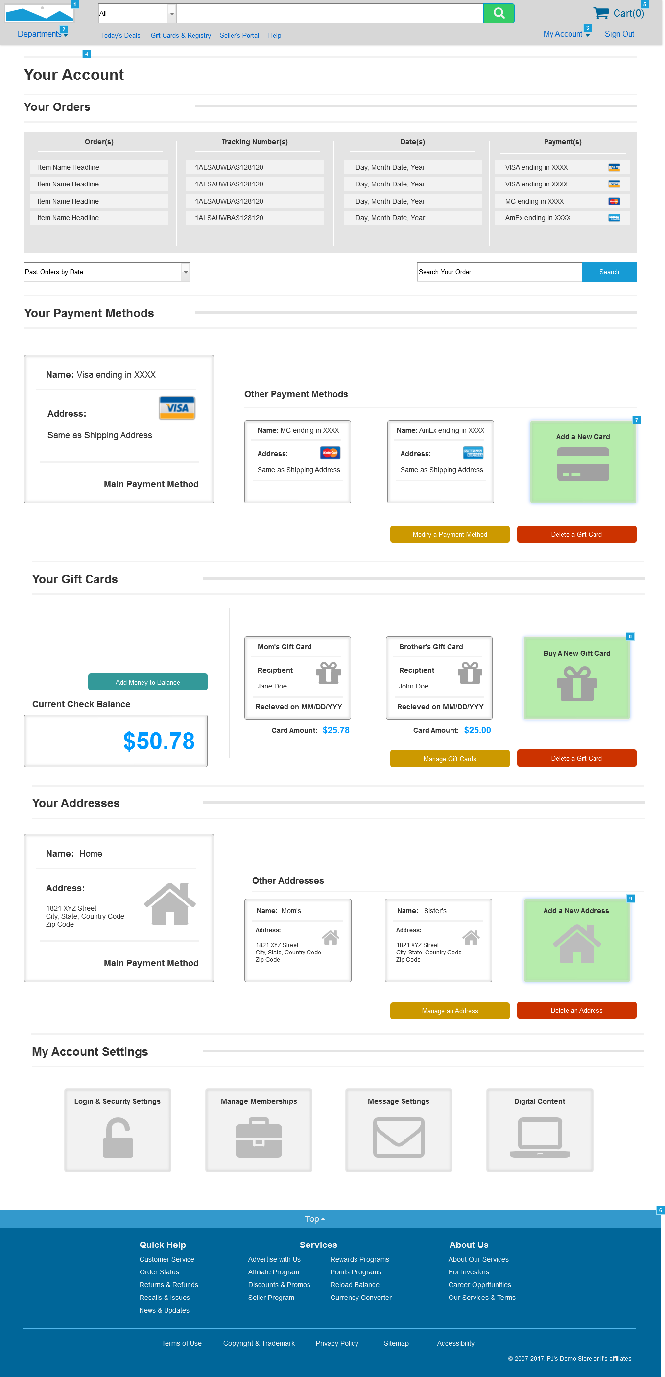

* + 1. Widget Table

|  |  |  |
| --- | --- | --- |
| Footnote | Name | Interactions |
| 1 | LogoImg | OnClick:  Case 1:  Open Home in Current Window |
| 2 | link_pop_Departments | OnClick:  Case 1:  Toggle pop_Toys, pop_Health&Beauty, pop_Home&Garden, pop_Computers, pop_Games, pop_Music, pop_Movies, pop_Books, pop_Clothing, pop_Appliances, pop_Electronics, Dept_PopOutPanel_Main |
| 3 | link_MyAccount | OnClick:  Case 1:  Toggle Account_PopOutPanel_Main, link_Watchlists, link_LinkProducts, link_RegisterSeller, link_PointsAwards, link_Wallet, link_Addresses, link_PaymentMethods, link_Memberships, link_Subscriptions, link_Recommendations, link_Lists, link_Orders, link_Account |
| 4 | pop_Electronics | OnClick:  Case 1:  Open DepartmentPageExample in Current Window |
| 5 | CartLink | OnClick:  Case 1:  Open CartPageExample in Current Window |
| 6 | ToTop_Link_Hotspot | OnClick:  Case 1:  Scroll to Widget |
| 7 |  | OnClick:  Case 1:  Open AddNewCreditCard in Current Window |
| 8 |  | OnClick:  Case 1:  Open SelectNewGiftCard in Current Window |
| 9 |  | OnClick:  Case 1:  Open AddNewAddress in Current Window |

* 1. AddNewCreditCard
     1. User Interface

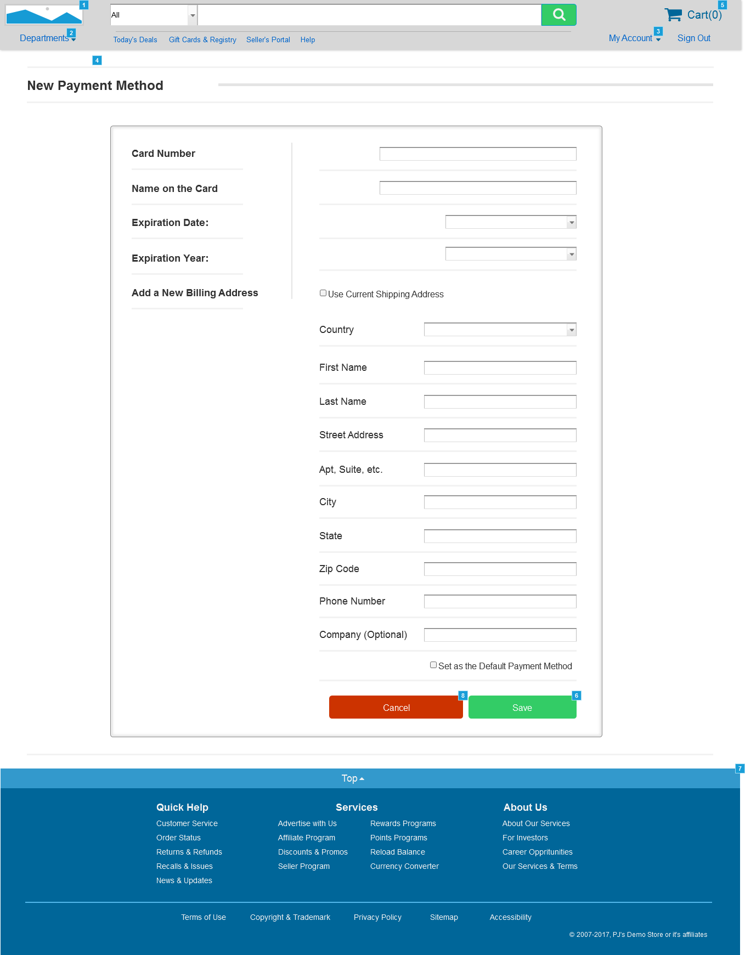

* + 1. Widget Table

|  |  |  |
| --- | --- | --- |
| Footnote | Name | Interactions |
| 1 | LogoImg | OnClick:  Case 1:  Open Home in Current Window |
| 2 | link_pop_Departments | OnClick:  Case 1:  Toggle pop_Toys, pop_Health&Beauty, pop_Home&Garden, pop_Computers, pop_Games, pop_Music, pop_Movies, pop_Books, pop_Clothing, pop_Appliances, pop_Electronics, Dept_PopOutPanel_Main |
| 3 | link_MyAccount | OnClick:  Case 1:  Toggle Account_PopOutPanel_Main, link_Watchlists, link_LinkProducts, link_RegisterSeller, link_PointsAwards, link_Wallet, link_Addresses, link_PaymentMethods, link_Memberships, link_Subscriptions, link_Recommendations, link_Lists, link_Orders, link_Account |
| 4 | pop_Electronics | OnClick:  Case 1:  Open DepartmentPageExample in Current Window |
| 5 | CartLink | OnClick:  Case 1:  Open CartPageExample in Current Window |
| 6 |  | OnClick:  Case 1:  Open NewCreditCardSaved in Current Window |
| 7 | ToTop_Link_Hotspot | OnClick:  Case 1:  Scroll to Widget |
| 8 |  | OnClick:  Case 1:  Open MyAccountPageExample in Current Window |

* 1. NewCreditCardSaved
     1. User Interface

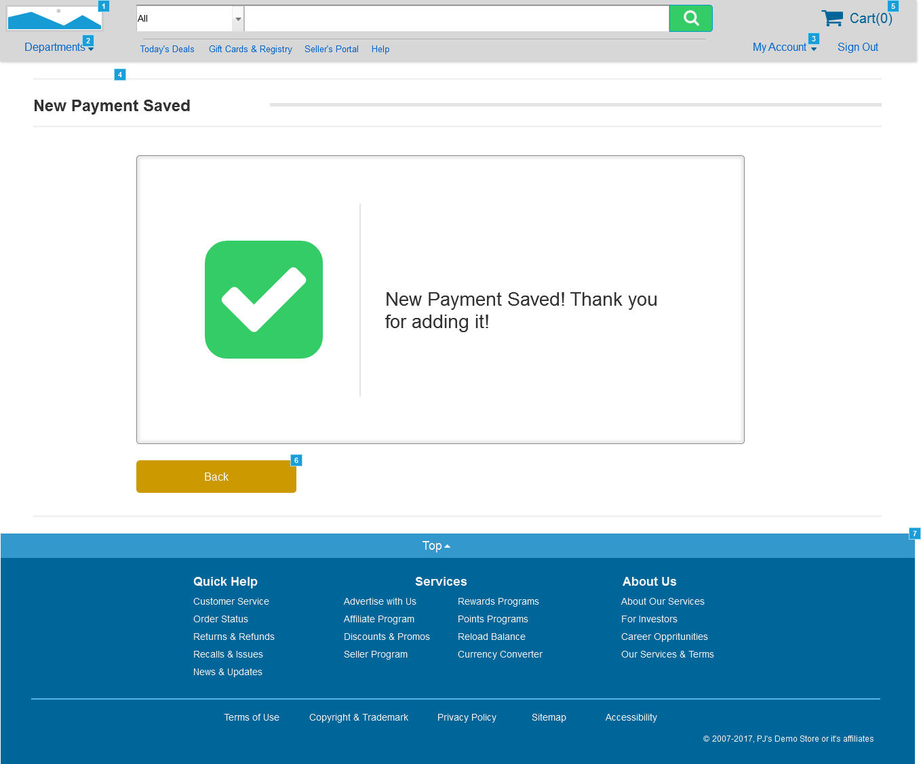

* + 1. Widget Table

|  |  |  |
| --- | --- | --- |
| Footnote | Name | Interactions |
| 1 | LogoImg | OnClick:  Case 1:  Open Home in Current Window |
| 2 | link_pop_Departments | OnClick:  Case 1:  Toggle pop_Toys, pop_Health&Beauty, pop_Home&Garden, pop_Computers, pop_Games, pop_Music, pop_Movies, pop_Books, pop_Clothing, pop_Appliances, pop_Electronics, Dept_PopOutPanel_Main |
| 3 | link_MyAccount | OnClick:  Case 1:  Toggle Account_PopOutPanel_Main, link_Watchlists, link_LinkProducts, link_RegisterSeller, link_PointsAwards, link_Wallet, link_Addresses, link_PaymentMethods, link_Memberships, link_Subscriptions, link_Recommendations, link_Lists, link_Orders, link_Account |
| 4 | pop_Electronics | OnClick:  Case 1:  Open DepartmentPageExample in Current Window |
| 5 | CartLink | OnClick:  Case 1:  Open CartPageExample in Current Window |
| 6 |  | OnClick:  Case 1:  Open MyAccountPageExample in Current Window |
| 7 | ToTop_Link_Hotspot | OnClick:  Case 1:  Scroll to Widget |

* 1. SelectNewGiftCard
     1. User Interface

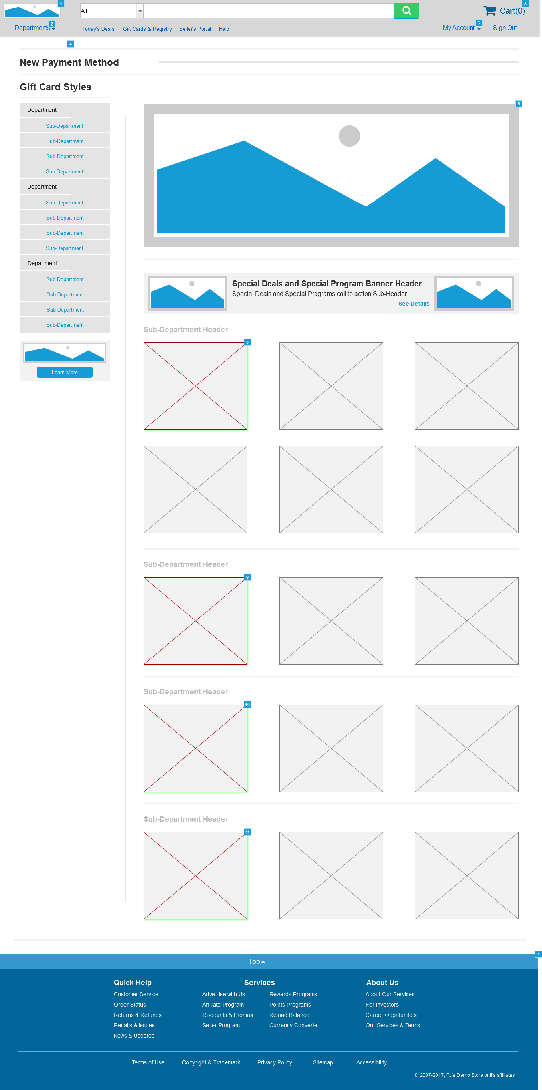

* + 1. Widget Table

|  |  |  |
| --- | --- | --- |
| Footnote | Name | Interactions |
| 1 | LogoImg | OnClick:  Case 1:  Open Home in Current Window |
| 2 | link_pop_Departments | OnClick:  Case 1:  Toggle pop_Toys, pop_Health&Beauty, pop_Home&Garden, pop_Computers, pop_Games, pop_Music, pop_Movies, pop_Books, pop_Clothing, pop_Appliances, pop_Electronics, Dept_PopOutPanel_Main |
| 3 | link_MyAccount | OnClick:  Case 1:  Toggle Account_PopOutPanel_Main, link_Watchlists, link_LinkProducts, link_RegisterSeller, link_PointsAwards, link_Wallet, link_Addresses, link_PaymentMethods, link_Memberships, link_Subscriptions, link_Recommendations, link_Lists, link_Orders, link_Account |
| 4 | pop_Electronics | OnClick:  Case 1:  Open DepartmentPageExample in Current Window |
| 5 | CartLink | OnClick:  Case 1:  Open CartPageExample in Current Window |
| 6 | MainPageSlideShow | OnClick:  Case 1:  Open ProductPageExample in Current Window |
| 7 | ToTop_Link_Hotspot | OnClick:  Case 1:  Scroll to Widget |
| 8 | link_MoreItems_Med2 | OnClick:  Case 1:  Open AddNewGiftCard in Current Window |
| 9 | link_MoreItems_Med2 | OnClick:  Case 1:  Open AddNewGiftCard in Current Window |
| 10 | link_MoreItems_Med2 | OnClick:  Case 1:  Open AddNewGiftCard in Current Window |
| 11 | link_MoreItems_Med2 | OnClick:  Case 1:  Open AddNewGiftCard in Current Window |

* 1. AddNewGiftCard
     1. User Interface

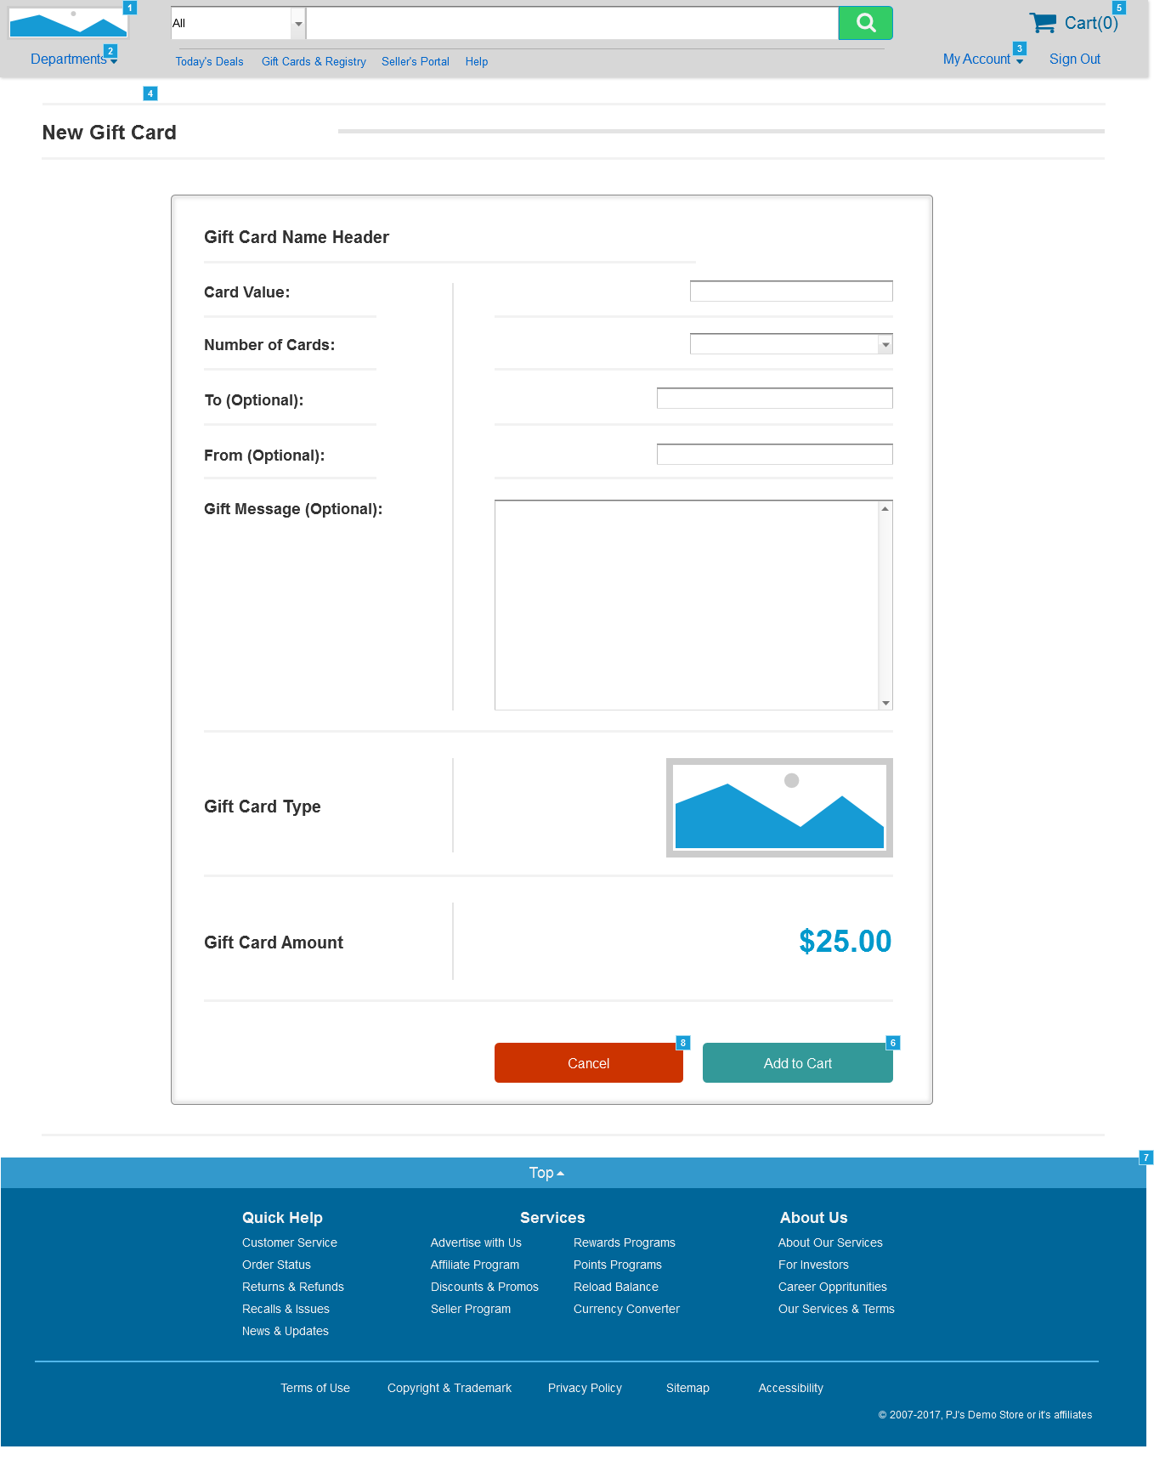

* + 1. Widget Table

|  |  |  |
| --- | --- | --- |
| Footnote | Name | Interactions |
| 1 | LogoImg | OnClick:  Case 1:  Open Home in Current Window |
| 2 | link_pop_Departments | OnClick:  Case 1:  Toggle pop_Toys, pop_Health&Beauty, pop_Home&Garden, pop_Computers, pop_Games, pop_Music, pop_Movies, pop_Books, pop_Clothing, pop_Appliances, pop_Electronics, Dept_PopOutPanel_Main |
| 3 | link_MyAccount | OnClick:  Case 1:  Toggle Account_PopOutPanel_Main, link_Watchlists, link_LinkProducts, link_RegisterSeller, link_PointsAwards, link_Wallet, link_Addresses, link_PaymentMethods, link_Memberships, link_Subscriptions, link_Recommendations, link_Lists, link_Orders, link_Account |
| 4 | pop_Electronics | OnClick:  Case 1:  Open DepartmentPageExample in Current Window |
| 5 | CartLink | OnClick:  Case 1:  Open CartPageExample in Current Window |
| 6 |  | OnClick:  Case 1:  Open CartPageExample in Current Window |
| 7 | ToTop_Link_Hotspot | OnClick:  Case 1:  Scroll to Widget |
| 8 |  | OnClick:  Case 1:  Open MyAccountPageExample in Current Window |

* 1. AddNewAddress
     1. User Interface

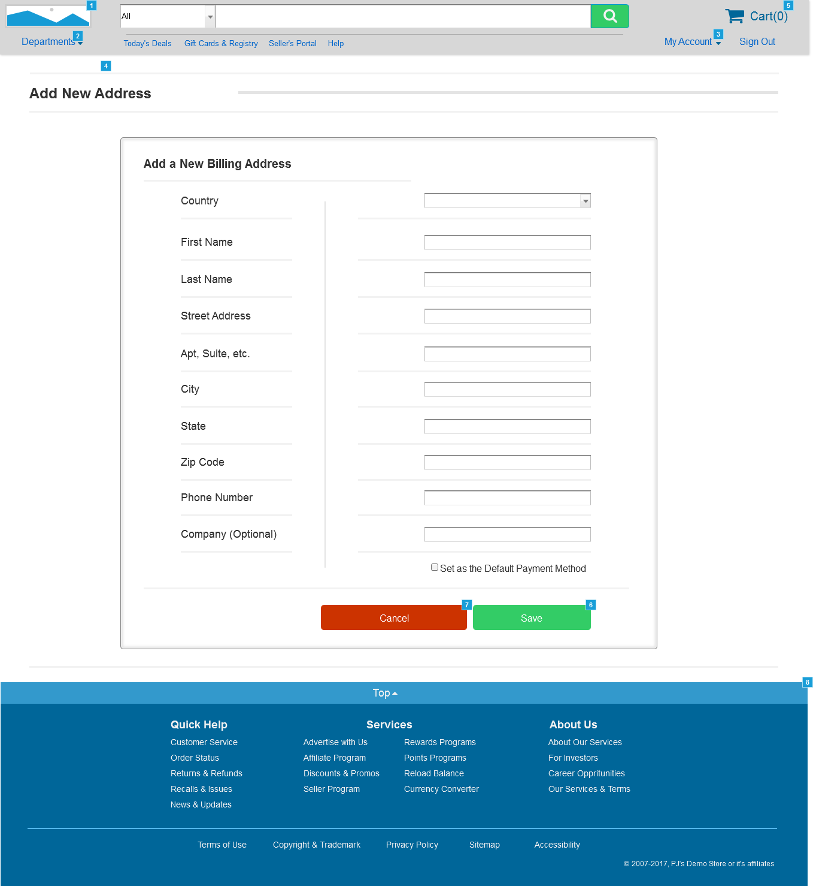

* + 1. Widget Table

|  |  |  |
| --- | --- | --- |
| Footnote | Name | Interactions |
| 1 | LogoImg | OnClick:  Case 1:  Open Home in Current Window |
| 2 | link_pop_Departments | OnClick:  Case 1:  Toggle pop_Toys, pop_Health&Beauty, pop_Home&Garden, pop_Computers, pop_Games, pop_Music, pop_Movies, pop_Books, pop_Clothing, pop_Appliances, pop_Electronics, Dept_PopOutPanel_Main |
| 3 | link_MyAccount | OnClick:  Case 1:  Toggle Account_PopOutPanel_Main, link_Watchlists, link_LinkProducts, link_RegisterSeller, link_PointsAwards, link_Wallet, link_Addresses, link_PaymentMethods, link_Memberships, link_Subscriptions, link_Recommendations, link_Lists, link_Orders, link_Account |
| 4 | pop_Electronics | OnClick:  Case 1:  Open DepartmentPageExample in Current Window |
| 5 | CartLink | OnClick:  Case 1:  Open CartPageExample in Current Window |
| 6 |  | OnClick:  Case 1:  Open MyAccountPageExample in Current Window |
| 7 |  | OnClick:  Case 1:  Open MyAccountPageExample in Current Window |
| 8 | ToTop_Link_Hotspot | OnClick:  Case 1:  Scroll to Widget |